Executive Summary

Strategic Purpose  The ProGrade Load Building Tool converts brand-specific stacking knowledge into a repeatable, team-independent workflow — enabling fulfillment and sales teams to design, validate, and refine trailer loads without relying on shipping experts for every fit decision.  Hosted within ATW’s Azure environment at https://cot-freight-tool-cddsc8hqe8caeuf3.eastus-01.azurewebsites.net/prograde/ | Why It Matters  - Reduces key-person dependency in daily shipping and fulfillment  - Improves trailer utilization through standardized stacking rules  - Accelerates load planning, customer response, and approval cycles  - Creates a durable training platform for future planners and sales teams

Brand Paths, Users, and Core Value
Brand | Primary User Group | Core Business Value
PJ | Sales representatives | Build customer-ready load scenarios in real time; identify incremental units that improve freight economics and customer margin.
Big Tex | Order fulfillment team | Independently validate non-standard load mixes, reducing approval bottlenecks with shipping leadership.
B-Wise | TBD | Extend the same value proposition to improve utilization consistency and reduce tribal knowledge dependency risk.

End-to-End Workflow

1  Select Brand  Brand cards (left panel) | ▶ | 2  Start Session  New load or resume | ▶ | 3  Sketch Load  Drag & drop SKUs | ▶ | 4  Close Gap  Inventory Gap Finder | ▶ | 5  Review & Export  PDF for fulfillment

Operating Guardrail: This Tool Is Decision Support — Not a Compliance Authority
Final shipping release still requires carrier judgment and regulatory review (state height limits, overhang, route-specific constraints). Confirm truck profile early to avoid late-stage redesign. Maintain SKU dimensions and stack assumptions as controlled operational data.

Business Value and Expected Outcomes

Key Operational Outcomes
- Reduce single-person dependency in load design decisions
- Reduce time spent by shipping directors and load engineers on routine fit validation
- Improve trailer utilization and load quality through standardized configuration logic
- Accelerate training readiness for future planners and support team
- Faster customer-facing decisions, particularly in PJ sales workflows
- Faster inventory movement by surfacing feasible fill candidates that are currently on hand
- Stronger cross-functional alignment — sales, fulfillment, and shipping operating from one consistent logic standard

Use Cases by Brand

Brand | Typical User Group | Typical Trigger | Business Benefit
PJ | Sales representatives | Customer requests quote or load feasibility check | Faster customer response; improved freight absorption recommendations.
Big Tex | Order fulfillment team | Non-standard or mixed category load request | Faster internal decisioning without escalating each scenario to shipping manager (Jake M).
B-Wise | TBD | TBD | Similar benefits as other brands, including reduced dependency risk and improved load building process consistency across the network.

Core Workflow With Brand-Specific Notes

The ProGrade Load Building Tool follows a consistent five-step workflow across all brand paths. Brand-specific notes are called out within each step.

Step 1 — Select Account and Initialize Session
User accounts are pre-configured for each brand's target user group. Select an account from the dropdown and click Continue with Selected Account to proceed. To add a new account, enter the user’s name in the Add New Account field at the bottom of the page.

1  Select Account  Choose from dropdown | ▶ | 2  Select Brand  PJ / Big Tex / B-Wise | ▶ | 3  New or Resume  Start new or continue | ▶ | 4  Confirm Profile  53_step_deck / flatbed | ▶ | 5  Begin Build  Proceed to load builder

From the sessions page, users can also review a summary of prior loads or directly export a PDF of any previous session.

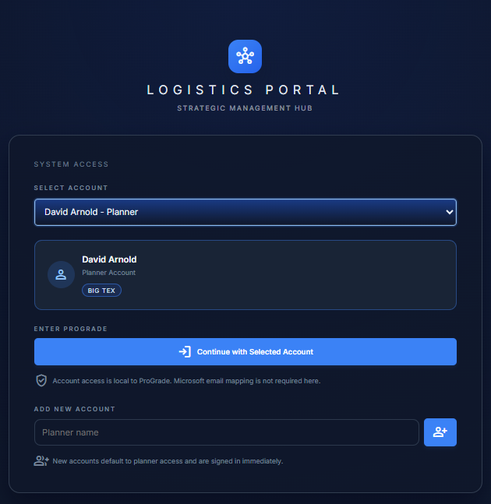
Figure 1. Account selection page — landing page used to select tool-administered accounts

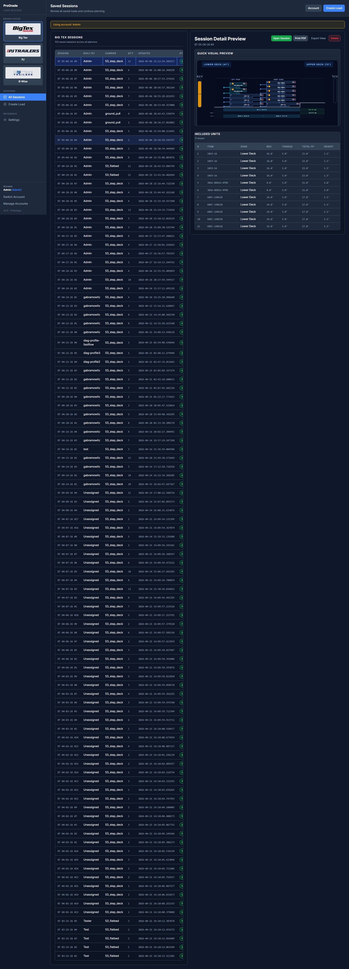
Figure 2. ProGrade sessions workspace used to start or resume the load build process.

Step 2 — Build and Refine the Load

1  Add Units  Category → Model → Item | ▶ | 2  Drag & Drop  Assign stack positions | ▶ | 3  Monitor Meters  Capacity & fit status | ▶ | 4  Adjust  Resolve fit conflicts

- Add units from the SKU list by navigating: Category → Model → Item.
- Drag and drop units into desired stack positions. Options include starting new stacks on each deck or adding to existing stacks.
- Monitor the real-time schematic and capacity meters to validate load fill.
- Adjust unit orientation and placement as needed to resolve fit conflicts.

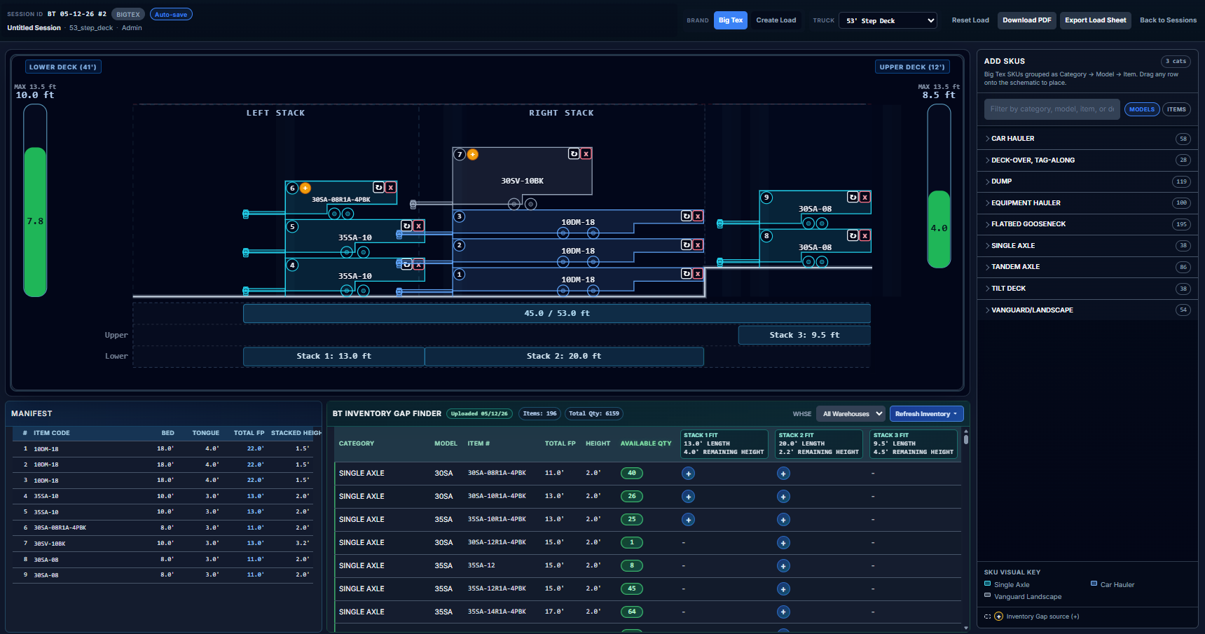
Figure 4. Load builder workspace — SKU add table (right), load schematic (bottom center), freight manifest and Inventory Gap Finder (bottom left).

Outcome of This Step
Teams can confirm operational viability visually before escalating for shipping leadership review — reducing unnecessary back-and-forth and approval delays.

Step 3 — Close Remaining Capacity with Inventory Gap Finder

What the Inventory Gap Finder Does
The Gap Finder matches open trailer space to real SKU geometry and current on-hand inventory, then recommends units that can complete the load more efficiently. This improves utilization, accelerates inventory movement, and supports practical upsell conversations — for example: “You’re already paying for this freight lane; adding one more unit may improve your delivered economics.”

1  Open Gap Finder  Bottom of load builder | ▶ | 2  Apply Filter  Warehouse location | ▶ | 3  Review Candidates  Gap footage & SKUs | ▶ | 4  Add Units  Confirm fit & add

- As the load is built, the Inventory Gap Finder panel surfaces eligible fill candidates automatically.
- Apply the warehouse filter to scope suggestions to available on-hand inventory.
- Review remaining gap footage and candidate items surfaced by the tool.
- Add units that satisfy stack constraints and current inventory availability.


Figure 3. Inventory Gap Finder panel — candidate SKUs with remaining gap footage and stack-fit validation columns.

Settings and Assumption Management

Settings are the operational knowledge base that powers the ProGrade Load Building Tool. They encode brand-specific stacking behavior and space-consumption assumptions. Keeping them accurate is essential — incorrect dimensions cascade directly into incorrect fit recommendations across every load that references that SKU.

What Is Configured in Settings
- SKU catalog by brand and category
- Key dimensions by SKU: deck length, tongue length, stack heights, and height envelopes
- Stacking behavior and space-consumption assumptions
- Trailer profiles (e.g., 53_step_deck, 53_flatbed, ground_pull)
- Tongue profile conventions, including bumper-pull vs. gooseneck behavior where applicable

Process: Adding or Editing a SKU

1  Open Settings | ▶ | 2  Select Brand Tab  PJ / Big Tex / B-Wise | ▶ | 3  Search SKU First  Avoid duplicates | ▶ | 4  Add or Edit Fields  Dimensions & stacking | ▶ | 5  Save & Re-Validate  Refresh open sessions

- Open Settings within the ProGrade Load Building Tool.
- Select the relevant brand tab (PJ Standards, Big Tex Standards, or B-Wise Standards).
- Search for the existing SKU first to avoid creating duplicates.
- Add the new SKU or edit existing fields (dimensions and stack assumptions).
- Save settings, then re-open or refresh any affected sessions and re-validate load fit before final export.

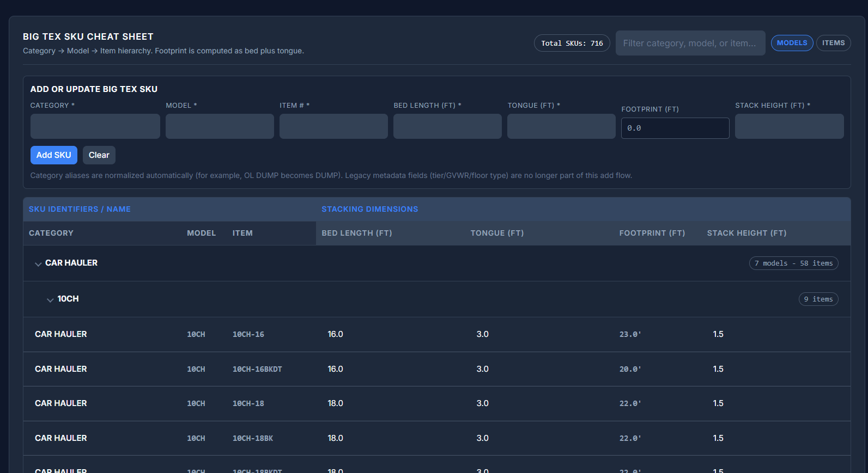
Figure 4. Settings workspace — brand-specific tabs for managing SKU dimensions, stack assumptions, and trailer profile configurations.

Quality Rule
Treat every SKU edit as an operationally important change. Incorrect dimensions cascade directly into incorrect fit recommendations across all active loads referencing that SKU.

How the Inventory Gap Finder Uses Settings
The Inventory Gap Finder is not a separate rule system — it depends on three inputs:
- Current load geometry (remaining space and active stack constraints)
- SKU assumptions from Settings
- Available inventory snapshot data (when uploaded)
Accurate settings directly determine the quality of gap-fill recommendations.
Operational Guardrails and Common Mistakes

Handoff, Ownership, and Support Model

A) Recommended Ownership Structure

Area | Recommended Owner | Cadence
SKU dimensions and stack assumptions | Brand shipping leads  - PJ: David Arnold and Shawn Williamson  - BT: Jake McIntee  - BW: TBD | Ad hoc updates as SKUs change
New user training | Brand shipping leads (see above) or existing user groups familiar with the tool | As needed
Tool administration and support triage | ATW IT Team | Ongoing

B) Support Escalation Path

Issue Type | First Contact
Workflow or usage question | Brand-specific shipping manager
Data or assumption issue | Brand-specific shipping manager
Tool behavior issue or bug | ATW IT development support

